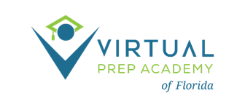
GOVERNING BOARD ANNUAL MEETING
November 16, 2023- 2:00 pm ET
Microsoft Teams meeting
Click here to join the meeting
Or join by entering a meeting ID
Meeting ID: 236 230 986 837; Passcode: K38x6d
Or call in (audio only)
+1 540-566-5080, 969223847#; ID: 969 223 847#
AGENDA

- Call to Order – S. Johns

- Roll Call- S. Johns

- Routine Business- S. Johns
  - Approval of Agenda
  - Approval of 10/18/23 Board Meeting minutes

- Information Items
  - State of the School Report – B. Santiago and M. Stokke Larson
  - Financial Update – E. DePersis

- Action Items
  - Approval of Invoices
  - Approval of New Board Member

- Additional Comments from the Board
  - Next board meeting date: December 21, 2023

- Public Comment

- Adjournment

