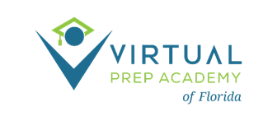
GOVERNING BOARD ANNUAL MEETING
October 18, 2023- 2:00 pm ET
Microsoft Teams meeting
Click here to join the meeting
Or join by entering a meeting ID
Meeting ID: 236 230 986 837; Passcode: K38x6d
Or call in (audio only)
+1 540-566-5080, 969223847#; ID: 969 223 847#
AGENDA

- Call to Order – S. Johns

- Roll Call- S. Johns

- Routine Business- S. Johns
  - Approval of Agenda
  - Approval of 9/21/23 Board Meeting minutes

- Information Items
  - State of the School Report – B. Santiago and M. Stokke Larson
  - Preliminary Projected Enrollment SY 2024-2025
  - Financial Updates – E. DePersis & S. Narcisse
    - Fiscal Audit 2022-2023

- Action Items
  - Proclamation: National Bullying Prevention Month – October 2023
  - Approval of Invoices
  - Approval of School Improvement Plan 2023-2024
  - Approval to Renew 501(c)(3) Annual 990 Form

- Additional Comments from the Board
  - Next board meeting date: November 16, 2023

- Public Comment

- Adjournment

